Product Description

CG100-airbag tool exclusively designed to read Tricore MCU’s over CAN-bus.Supports Read/Write EEPROM function for secured and non-secured SAC-TC1766 SAC-TC1767 SAC-TC1796 SAC-TC1797 microcontrollers.comes with Mileage, DPF, ECU system time, ISN built-in calculators.Edit CRC Eeprom.

**CG100 PROG III Full Version Airbag Restore Devices including All Function of Renesas SRS and Infineon XC236x FLASH  
  
Top 7 Reasons to Buy CG100 PROG III:**  
  
1. Latest Version: V6.5.2.2  
2. Including All Function of Renesas SRS   
3. Support read and write EEPROM, support non-secure BMW DDME ECU microcontroller.  
4. CG100 with built-in calculator, support calculate ISN, VIN and program CRC EEPROM  
5. CG100 now support CAS3 CAS3+CAS4 CAS4+ Key Programming  
6. CG100 can splite the quality for CAS Data  
**7. With CG100 ATMEGA Adapter in package.  
  
CG100 ATMEGA Adapter for CG100 PROG III Airbag Restore Devices with 35080 EEPROM and 8pin Chip reading and writing**  
   
**The ATM adapter suppports:**  
   
**35080:**M35080DQ080, M35080DQ160, M35080 3/6, M35080 V6 / VP (5 seconds to adjust mileage: directly read and write)  
**ATMEGA Parallel:**MEGA8L, MEGA48, MEGA88 (can erase the second-hand ATMEGA8L for re-use) MEGA16, MEGA32, MEGA169  
**24 Series:**24C01 24C02 24C04 24C08 24C16 24C32 24C64 24C128  (read and write)  
**93 Series:**93c46 93c56 93c57 93C66 93c76 93c86   (read and write)      
**25 Series:**25010 25020 25040 25080 25160 25320 25640 25128 25256 (read and write)  
**95 Series:**95010 95020 95040 95080 95160 95320 95640 95128 95256 95512 (read and write)  
   
**Add 9S08GL16 CPU Parallel FLASH:**  
**AMD:** AM29BL802D (can erase the FAW REIZ MT34 immobilizer)  
  
**The software adopt to operate interface with wizard-style, data arbitrarily rewrite, MCU pin identification and detection, full support for CPU airbag computer repair.**  
  
**Supported operating systems software:**XP/WIN7/WIN8/32bit/64bit  
  
**1. Support and Adoption: Renesas**  
  
R5F61797, RF61725, R5F61723, R5F61721, the model in the computer are assembled as follows: Toyota, Honda, Subaru  
  
**2. Support and Adoption:**  
  
XC2060N-40F,XC2060M-104F,XC2336B-24F,XC2336B-40F,XC236  
1A-56F,XC2361A72F,XC2361E72F,XC2363A-56F,XC2363A-72F,XC2364A-56F,XC23  
64A-72F,XC2364A-104F,XC2365A-56F,XC2365A-72F,XC2365A-104F,XC2361B-24F,XC2361B-40F,XC2363B-24F,XC2361B-40F,XC2364B-24F,XC2364B-40F,XC2365B-24F,XC2365B-40F,the model in the computer are assembled as follows: Nissan, Suzuki, Hyundai, Ford, Mazda, Land Rover, Jaguar, GM.20seconds of read and write.this speed  supported  is exclusive  in the wordwide.  
  
**3.Support and Adoption: Freescale**  
  
MPC5604P(0M26V)(1M36W)the model in the computer are assembled as follows:Honda  
  
**4. Support and Adoption: ST**  
  
SPC560 the model in the computer are assembled as follows:Volkswagen  
  
**5. Support and Adoption: CPU**  
  
ATMEGA169, ATMEGA32, ATMEGA16, ATMEGA8, ATMEGA88, ATMEGA48. The instrument model tune number of kilometers  
  
**CG100 PROG Airbag Restore Devices Support for MCU model:**  
  
R5F61721  R5F61723 R5F61725 R5F61797  
XC2336A XC2336B XC2361A XC2361B XC2361E XC2360A XC2360B XC2387C XC2320S XC2310S  Time of reading and writting as 25seconds  
0M26V MPC5604  
SPC560P50  
  
**CG100 PROG III Update Policy:**  
  
1. Update Online Free for One Year.  
2. It will cost $89 for [**CG100 One Year Update Service.**](https://www.uobdii.com/wholesale/cg-cg100-prog-iii-1-year-software-service.html) If you don't want to pay update cost, your device can still work on old version.  
3. If your CG100 is too old, please update to V6.0.0.0 first, then use the newest version.  
  
**CG100 PROG III Instruction:**  
  
**CG-100 Host Unit**  
A powerful programming function support variety of modules data repairing and total modules replacement.  
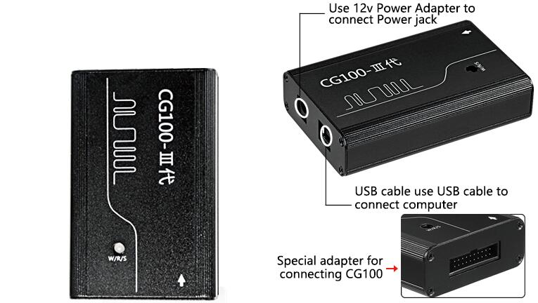  
  
**BDM+4 Adapter**  
This adapter is used with 12P welding line to repair various of instrument,airbag and module data  
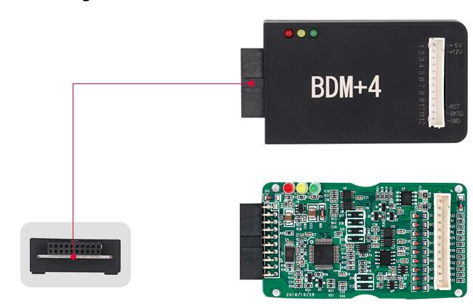  
  
**ATMEGA Adapter:**  
Apply to data repairing for all kinds of domestic ATMEGA instrument,support a variety of eight-pin chip airbag repairing and instrument calibration,support data repairing of chps 35080,160D,support reusing the second and ATMEGA chip which eradicated the old data,support the cancellation of FAW Wei Chi MT34 anti-theft.  
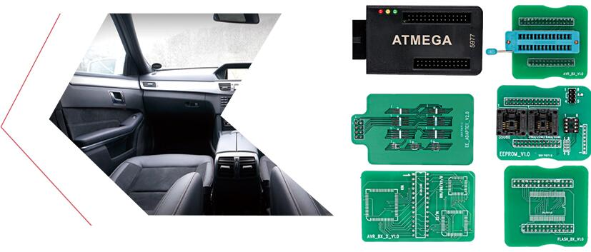  
  
**CAN Adapter:**  
Support BMW,Volkswagen,Bentley engine data repairing and module replacement,support domestic MT80,domestic MT60 engine data repair and module replacement.  
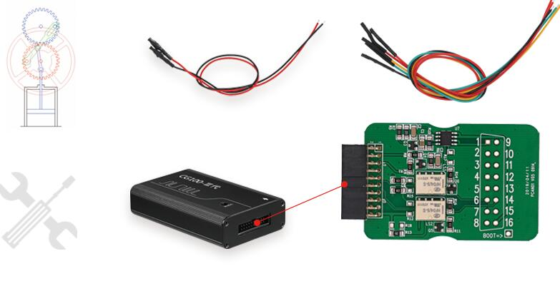  
  
**ATMEGA Welding Plate**  
Apply to various domestic ATMEGA instrument,support reusing the second hand ATMEGA chip which eradicated the old data.  
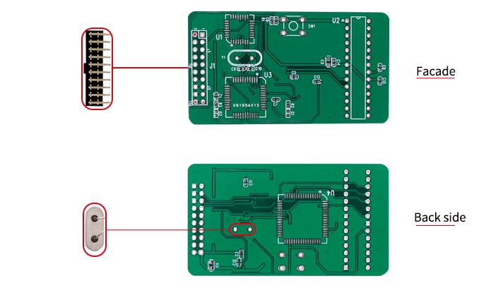  
  
**12P Welding Line**  
This line is used with BDM4+4 adapter to repair various of instrument,airbag and module data.  
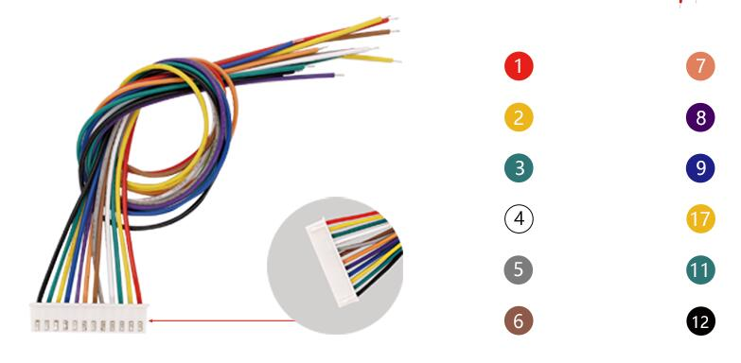  
  
**USB Connection Line**  
Used to connection of computer and equipment to ensure high-speed data communication  
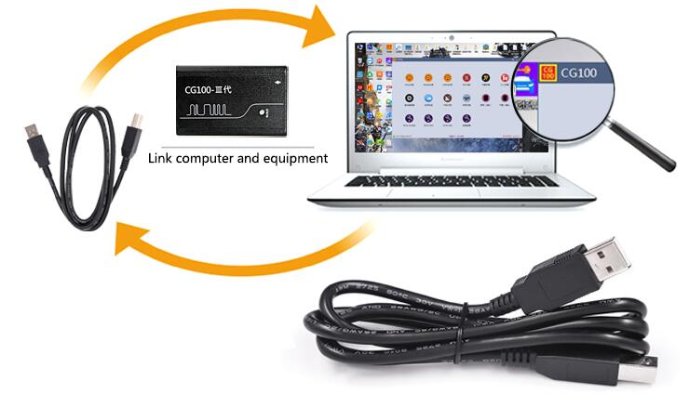  
  
**12V Power Supply**  
Supply power to equipment and modules to ensure stable voltage during operation  
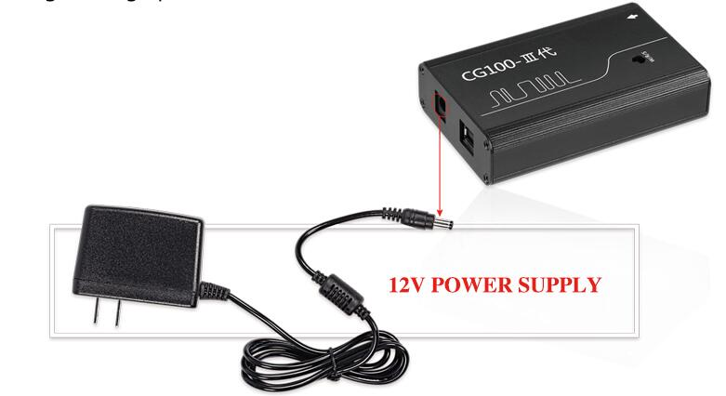  
  
  
**CGDI PROG III Software Display:**  
  
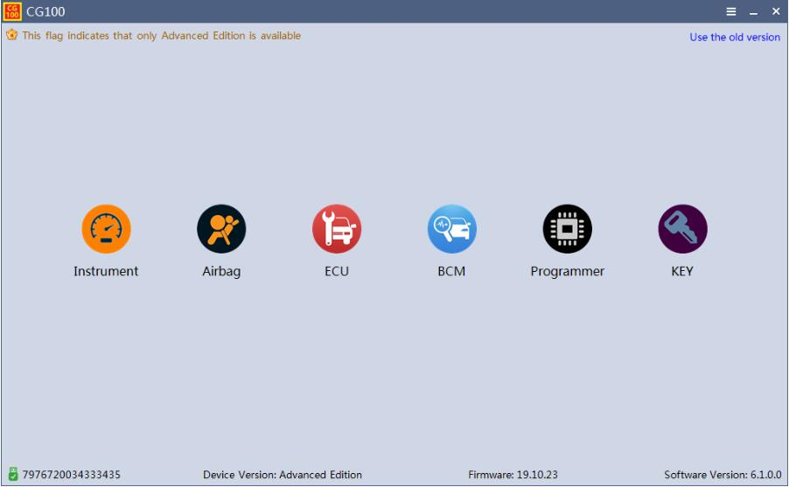  
**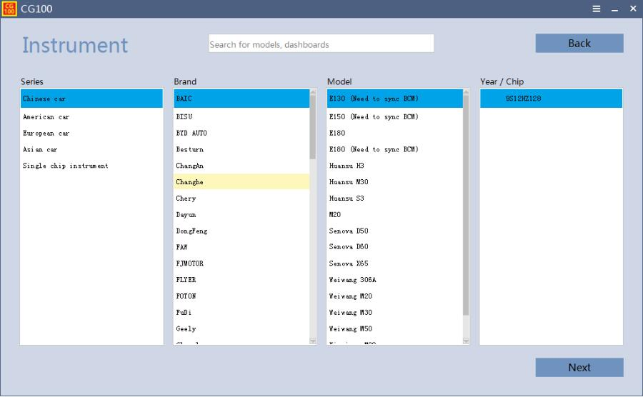  
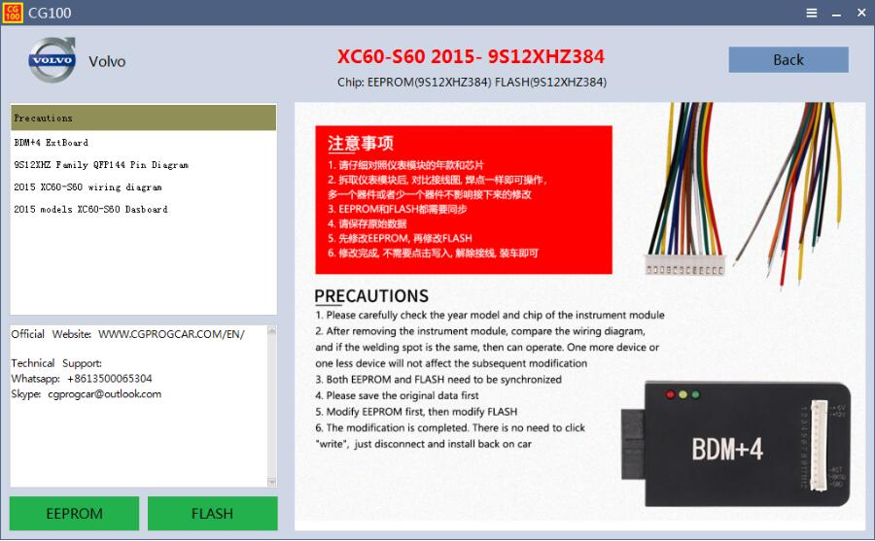  
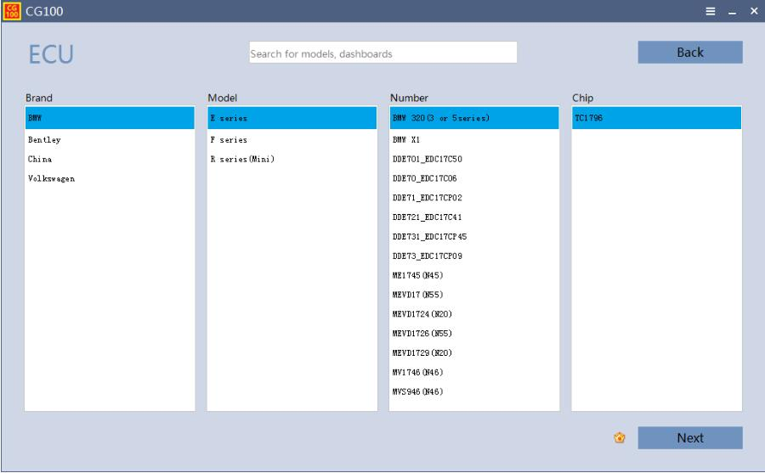  
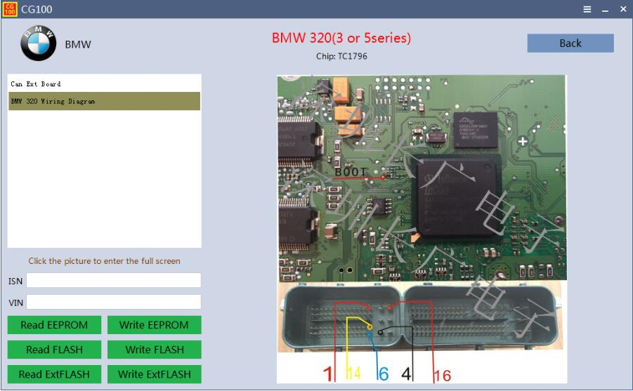  
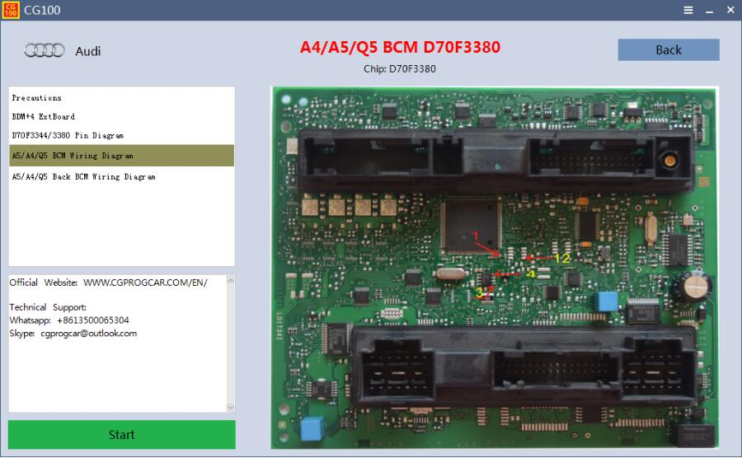**  
     
  
  
  
       
  
  
   

 

**CG100 PROG III Full Version Packing Including:**  
  
1pc x CG PRO III Programmer  
1pc x BDM+4 Adapter  
1pc x CAN Adapter  
12pcs x Welding Line  
1pc x USB Cable  
1pc x 12V Power Supply  
1pc x ATMEGA Adapter  
1pc x EEPROM Adapter  
1pc x AVR Adapter  
1pc x AVR V2.0 Adapter  
1pc x EEPROM-SO Adapter  
1pc x FLASH Adapter